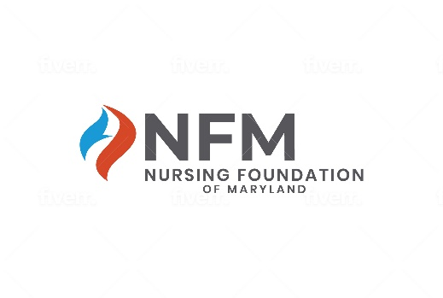
Nursing Foundation of Maryland, Inc
2023 SCHOLARSHIP APPLICATION FORM

This application form is for 2023 scholarships awarded through the NFM. The applicant must have an anticipated graduation date in 2023 or 2024. Please refer to “2023 Nursing Foundation of Maryland Scholarships” on the Nursing Foundation of Maryland, Inc. website www.NursingFoundationofMaryland.org or the Maryland Nurses Association website www.MNANursingNetwork.com for a list of available scholarships and scholarship-specific requirements.

Applicant’s Name: _____________________________________________________________________

Name of up to two scholarship(s) for which you are making application:

- _______________________________________________________

- ________________________________________________________

Personal Information | School Information
Street Address: | Name of College/University:
City/State: | Street Address:
Zip Code:
 | City/State:
School E-mail | Zip Code:
Home E-mail: | Dean’s Name:
Cell Phone: | Dean’s e-mail address:

In addition to the above, submit the following:

- Essay of 300 words or less to include, but not limited to:
  - Reason for applying
  - Goals in nursing
  - Demonstrated involvement in community service
  - Description of commitment to, and potential for nursing leadership

- Two Letters of Reference: Letters of reference should evaluate the candidate in at least two of the following areas: scholarship, community service, commitment to, and potential for, leadership in nursing.
  - One letter must be from a nursing faculty member
  - One letter may be from another faculty member, a former or current employer, or supervisor.

- School Transcript listing GPA

- Scholarship-specific requirements (if applicable)

- Signed and dated checklist (see next page)

2023 Nursing Foundation of Maryland Scholarship Application Checklist

___ Demographic information.

___ Identification of no more than two nursing scholarships to which you wish to make
application.

___ Anticipated date of graduation is 2023 or 2024.

___Two reference letters - at least one letter from a faculty member.

___ School transcript listing GPA.

___ Essay – 300 words or less. Sending more than 300 words may disqualify the
application.

___ If a Registered Nurse, must be a member of the Maryland Nurses Association
(MNA) at the time of application. If not currently a Registered Nurse, leave blank.

___ Have not received a scholarship from the NFM in the past.

___ I give permission to the NFM and MNA to use photo(s), excerpts from applications,
quotes, and follow-up information for purposes of promoting the NFM scholarships
and fundraising.

___ If selected for a scholarship, I will submit an electronic photo within two weeks of
notice.

___ If awarded a scholarship, I will be invited to attend the NFM Scholarship Event held
on October 13, 2023 (time to be announced later), during the MNA120th Annual
Convention at the Fontainebleau Resort, Ocean City, MD. The scholarship recipient
will receive a one-day complimentary convention registration for October 13, 2023.

___ If awarded a NFM scholarship, I agree submit to the NFM a thank-you message for
the scholarship donor within 3 months of receiving the scholarship.

____________________________________________________ ____________
Signature (electronic signature is acceptable) Date

All application materials must be received by midnight August 27th, 2023.

Applications received late, inaccurate, or incomplete will not be considered.

